

AM804001: Project Management
Assessment 2: Case Study – Project Management Plan

Study block 1
Date issued
Due date |  |  |  |  | Time
Delivery: |  | Submit to Turnitin via Moodle before deadline
Weighting |  | 70%
Marks out of |  | 100
Instructions |  | Complete this cover sheet and attach to you your assignment.  - This assignment must be your own work.  - Collusion, copying or plagiarism may result in disciplinary action.  - We advise that you keep a copy of this assignment.  - Word limit is 3000-3500 words  Refer to following website for reference related resources: http://www.cite.auckland.ac.nz/index.php?p=quickcite
We confirm that:

This is an original assessment and is entirely my own work.

Where ideas, tables, diagrams etc. of other writers have been used, we have acknowledged the source in every case.

This assignment has not been, nor will be, submitted as assessed work for any other academic course.
Student’s Name |  |  | ID No |  |  | Signature
Gielo Joseph Fernandez |  |  | 737214696 |  |  | Gielo
Date | April 2, 2025 |  |  | Cohort Number |  |  |  | 3

Table of Contents
Executive Summary 3
2. Background and Purpose 5
3. Project Scope 6
3.1. Objectives 7
3.2. Deliverables 7
3.3. Milestones 10
3.4. Technical requirements 11
3.4.1 Functional requirements 12
3.4.2 Non-functional requirement 13
3.5. Project Exclusions 15
3.6. Project Limitations 16
4. Project Assumptions 17
5. Methodology 18
5.1 Justification 18
5.2 Māori Value: how you can apply Māori values 19
6. Project Risks and Risk Management Plan 20
7. Project Organisation 22
8. Communications with Stakeholders 25
8.1 Stakeholders identification. 25
8.2 Communication plan 26
9. Change management plan 27
10. Project Estimation Technique 29
11. Budget 31
12. Quality Control and Audit 35
13. Project Closure 36
14. Appendices 37
15. References: 40

Executive Summary
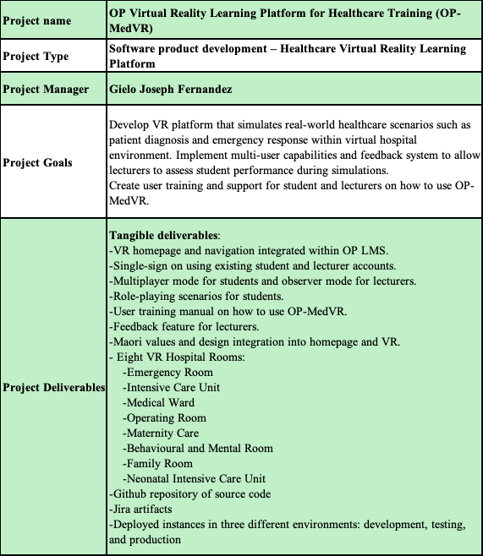

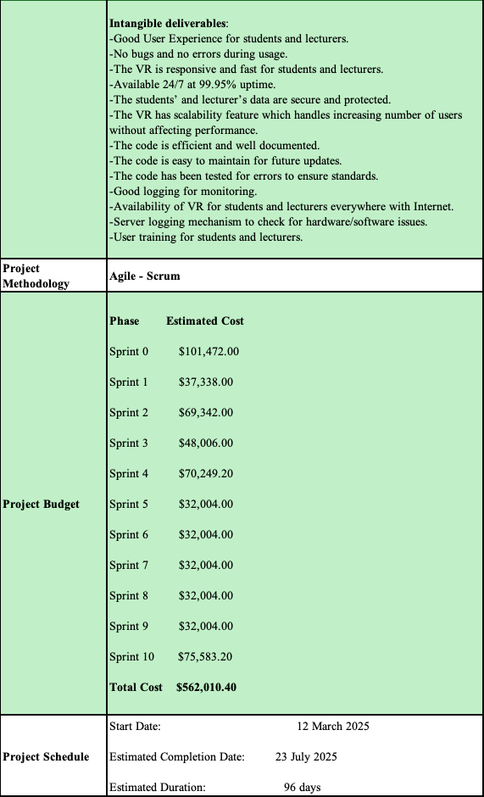

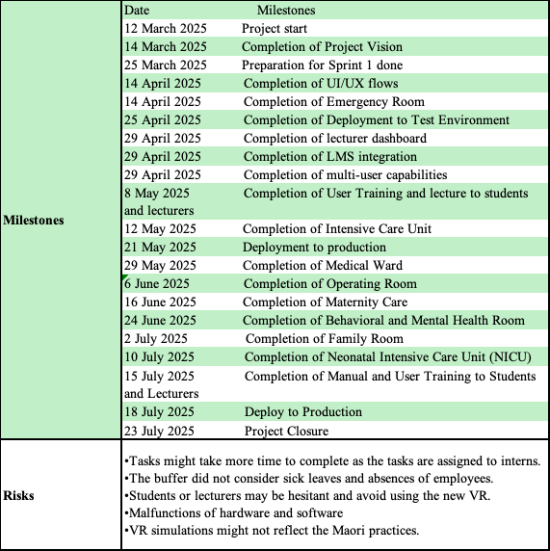

2. Background and Purpose

Otago Polytechnic will soon launch a Virtual Reality (VR) Learning Platform for its Nursing and Healthcare programs in Dunedin, enabling students to develop key medical skills in a virtual hospital environment. By replicating real-world scenarios, the VR platform will create a secure and supportive environment for students to build and perfect their clinical abilities, free from the stress or potential risks of hands-on practice in actual healthcare settings. This initiative reflects the institution’s dedication to preparing students for the challenges of modern healthcare through forward-thinking solutions.
Key features of this platform will be the eight different hospital rooms (Emergency Room, Intensive Care Unit, Medical Ward, Operating Room, Maternity Care, Behavioural and Mental Room, Family Room, and Neonatal Intensive Care Unit) that will be created in the VR world. Another key feature includes the ability for students to interact and collaborate with each other in real time. Multi-user capabilities will enable role-playing exercises that closely mimic real healthcare scenarios, helping students develop teamwork, decision-making, and communication skills. This immersive, hands-on approach will better prepare students for the challenges they will encounter in their future careers. Furthermore, the platform will integrate smoothly with the Polytechnic’s existing Learning Management System (LMS), allowing both students and lecturers to easily track progress and manage coursework
OP-MedVr will incorporate Māori health frameworks into its VR simulations, promoting both technical skills and cultural awareness in healthcare. It will feature realistic 3D environments and a feedback system for real-time instructor assessments and guidance.
The project aims to transform healthcare education with a NZD 562,010.40 budget and a 5-month timeline. It will provide thorough training for users and include a risk management plan to address potential challenges like tech issues and resistance to change.

3. Project Scope

The project scope defines the context, inputs, outputs, and functions of the system, outlining all necessary tasks, resources, timelines, decisions, and boundaries to meet the project's goals and deliverables. The Project Scope Statement (PSS) explains the project's purpose and necessary activities, helping all stakeholders understand the project's details. (Althiyabi & Qureshi, 2021).

3.1. Objectives
Project objectives define the actions needed to execute a project plan, with tangible or intangible milestones. They must follow the SMART criteria—specific, measurable, achievable, realistic, and time-bound—and align with the project's broader goals. Project objectives clarify team roles, align with stakeholder expectations, and include measurable factors like budget, quality, and timelines to track progress (Bridges, 2024).

3.2. Deliverables
Project deliverables are essential to ensure the success of data integration projects by providing a way to measure progress and manage expectations. Well-defined deliverables help maintain sanity by setting clear expectations and preventing stakeholders from constantly asking for more than what can be realistically delivered within the allotted time. Project deliverables act as a roadmap and a control mechanism for the integration project. They help to solidify base requirements and mappings, which in turn provides the team with more flexibility to handle last-minute requests. They also communicate what features and outcomes to expect from the project from its initiation to completion (Goldfedder, 2020).
There are two types of deliverables, tangible and intangible. Tangible deliverables refer to physical or quantifiable outcomes, like a product, prototype, or software application. These deliverables are solid and can be evaluated for their quality and level of completion. Intangible deliverables encompass non-physical results such as intellectual property, concepts, or the transfer of knowledge. Examples of these include business plans, patents, or project-related documentation (Kharlantseva, 2025).
Regarding OP-MedVR, the table below contains the tangible deliverables.
Table 1 Tangible Deliverables
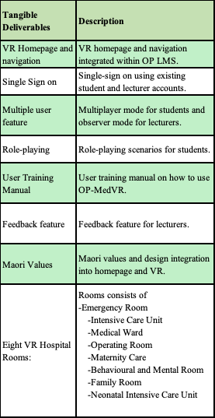

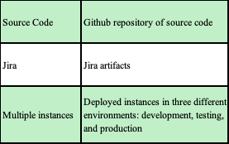
Regarding the intangible deliverables, the table below explains it more in detail.
Table 2 Intangible Deliverables
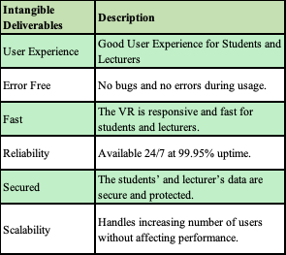

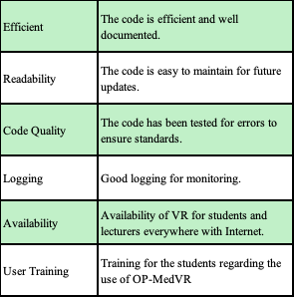

3.3. Milestones
In project management, milestones are defined as significant points or events within a project's timeline. Milestones serve as crucial reference points for tracking progress and assessing achievements against the project plan. Milestones can signify the completion of specific phases or the delivery of key deliverables. Milestones are used as benchmarks to measure how the project is advancing. By identifying when milestones are reached (or not reached), project managers can gauge whether the project is on track (Lock, 2017).
The table below discuss the project milestones of OP-MedVR in more detail.
Table 3 Project Milestones
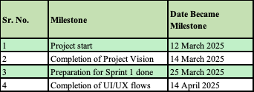
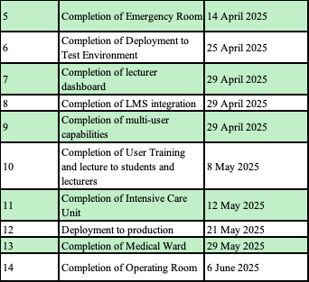
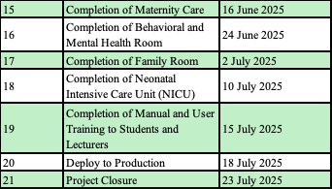

3.4. Technical requirements
In project management, technical requirements refer to the essential elements needed to ensure a system performs as expected, meeting the user’s specifications and expectations. Typically outlined in a technical requirements document, this document helps the team achieve a shared understanding of the technical needs necessary to ensure the success of the project or product. Technical requirements also offer insights that assist in estimating the required budget, utilizing the work breakdown structure, developing an accurate Gantt chart, and addressing risk management considerations (Espinheira, 2021).
Technical requirements are categorized into functional and non-functional, with a detailed discussion on OP-MedVR's requirements to follow.

3.4.1 Functional requirements
Functional requirements define the necessary features of a software solution, focusing on how it enables users to complete tasks (Rebrova, 2024). Functional requirements guide the development process, preventing wasted resources and enabling the creation of an efficient, well-designed solution (Fowler, 2010).
In the case of OP-MedVR, the table below shows the functional requirements in more detail.
Table 4 Functional Requirements
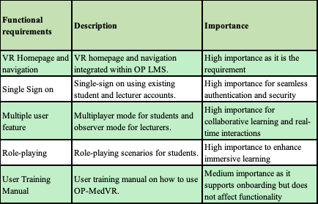

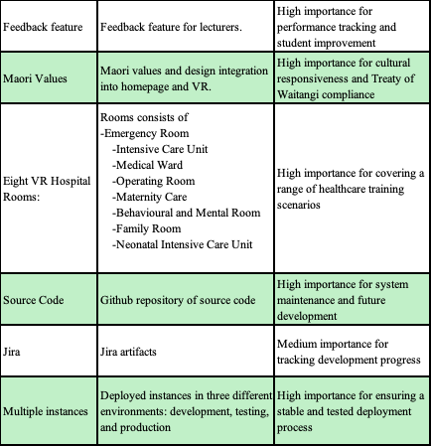

3.4.2 Non-functional requirement
In project planning, while factors like scalability, reliability, usability, availability, security and performance are not considered functional requirements, they are still crucial. Failing to address these aspects could result in not meeting user or stakeholder expectations or the business's needs (Krüger, 2024).
In the case of OP-MedVR, the table below contains the non-functional requirements in more detail.
Table 5 Non-Functional Requirements
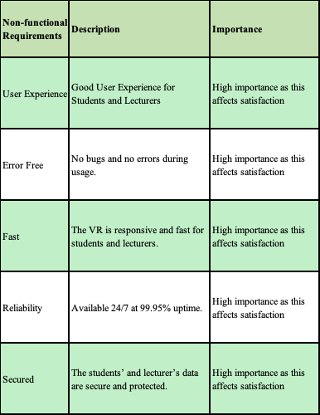

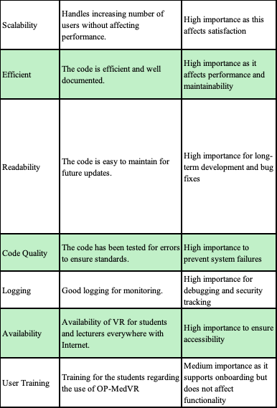

3.5. Project Exclusions
In project planning, it is necessary to include things that are not included in the project as this can lead to scope creep during the development of OP-MedVR. To avoid misunderstandings and manage expectations, project exclusion is mostly related to work not included in the project scope (Wootton, 2024).
In the case of OP-MedVR, the table below discusses the project exclusions in more detail.
Table 6 Project Exclusion
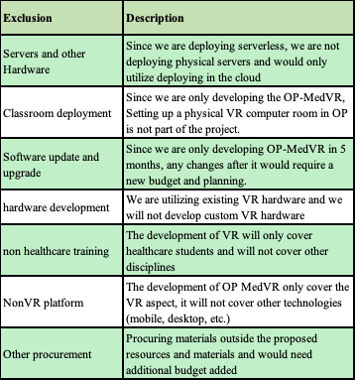

3.6. Project Limitations
In project planning, considering the limitations of available resources—such as budget, time, technology, and materials—is essential. These constraints shape what is feasible within the project and often guide its trajectory, with elements like time potentially affecting the quality of the final outcome (Erro, 2016).
In the case of OP-MedVR, the table below discusses the project limitations in more detail.
Table 7 Project Limitation
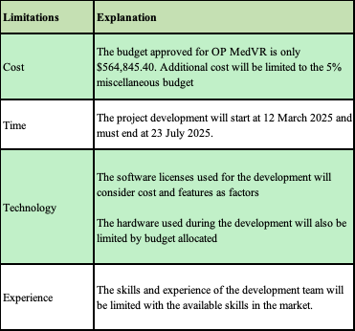

4. Project Assumptions

In project management, assumptions are accepted as true without concrete proof and evolve throughout the project lifecycle. Project managers rely on these assumptions for elements like market conditions, resources, technology, and scope to progress, as verifying every detail is impractical (Sharma, 2024).
Regarding OP-MedVR, the table below are the assumptions in this project.
Table 8 Project Assumptions
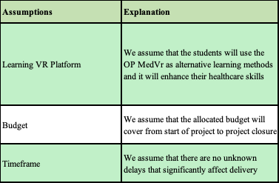

5. Methodology
Scrum is an agile framework for software development that focuses on delivering work in short, manageable cycles. It promotes flexibility and collaboration, enabling teams to adapt swiftly as they progress. Unlike traditional, linear development methods, Scrum encourages self-organizing teams. The approach fosters better results by having team members collaborate closely, both virtually and in person, rather than working in isolation. This open communication and teamwork help the project advance more smoothly and with flexibility (Sachdeva, 2016).
Scrum is a suitable methodology for OP-MedVR because it effectively manages evolving requirements, such as feedback from lecturers and students or updates to the curriculum. Its iterative approach allows for frequent deployments, enabling lecturers and students to review OP-MedVR early in the development process and provide timely feedback. As multiple hospital rooms are being developed, feedback from the first room (such as the emergency room) can be incorporated into the development of subsequent rooms, ensuring continuous improvement throughout the project.

5.1 Justification

Below are the justifications for why Scrum is the best fit for this initiative.
Firstly, Scrum’s iterative development process allows for continuous improvement and adaptation. The OPAIC VR platform project involves cutting-edge technology and requires frequent testing and refinement to ensure it meets the needs of students and lecturers, only scrum ideal to use in this type of project scenario. By breaking the project into smaller, manageable sprints, the development team can deliver incremental updates, gather feedback, and make necessary adjustments. This is particularly important for ensuring the platform’s immersive 3D environments, multi-user capabilities, and integrated feedback system function seamlessly (Schwaber & Sutherland, 2020).
Second, Scrum emphasizes collaboration and communication, which is critical for a project involving multiple stakeholders such as OPAIC VR platform project, stakeholders in this project will include among other students, lecturers, software developers, and healthcare professionals. The daily stand-ups, sprint reviews, and retrospectives will foster transparency and ensure that everyone is aligned with the project’s goals. Integrating Iwi/Māori health frameworks in this project is needed that is why the collaborative approach is needed, as it requires ongoing dialogue and input from diverse stakeholders (Rubin, 2012).
Thirdly, scrum is adopted because of Scrum’s flexibility that makes it ideal for addressing the uncertainties and challenges inherent in developing a VR platform. For instance, the risk management plan for technology malfunctions and user resistance can be continuously updated based on real-time feedback and testing. This adaptability ensures that potential issues are identified and resolved early, minimizing disruptions to the project (Sutherland & Sutherland, 2014).
Lastly, Scrum’s focus on delivering value incrementally ensures that the platform’s key features, such as role-playing for multiple participants and integration with the existing LMS, are prioritized and developed efficiently. This approach also allows for early user training, ensuring that students and lecturers become confident with the VR technology as it evolves (Mike, 2010).
In summary, Scrum's iterative, team-oriented, and adaptable approach makes it the ideal methodology for the VR Learning Platform project. It promotes ongoing enhancement, encourages stakeholder engagement, and guarantees the prompt delivery of high-quality, culturally relevant healthcare training solutions.

5.2 Māori Value: how you can apply Māori values
Implementing Māori values such as Whanaungatanga and Kaitiakitanga is necessary as it is needed to comply with NZQA and Māori Council standards. The team also hired a Cultural Consultant to help with implementing Māori Values. To implement Whanaungatanga and Kaitiakitanga, it is done in the following ways below:
Table 9 Maori Values for OP-MedVR
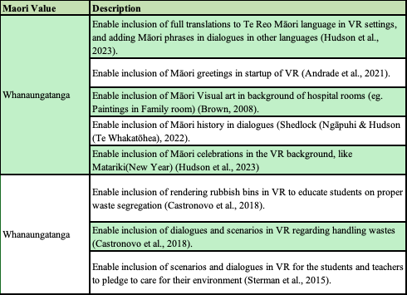

Māori principles such as Manaakitanga and Whanaungatanga should be incorporated into the OP-MedVR project in various ways. To foster Manaakitanga, the project team can promote a sense of worth and acceptance for each individual by prioritizing open dialogue, empathy, and inclusiveness. This could involve organizing regular team-building activities and cultivating a culture of belonging among all members.

6. Project Risks and Risk Management Plan
In project management, project risk refers to the probability that specific events or circumstances could adversely affect the project's goals and outcomes. It reflects the extent of vulnerability to potential negative events and the possible outcomes they could result in. Project risk can be characterized by the following factors: the risk event, likelihood of occurrence, and the potential impact. Consequently, risk management involves the process of identifying, assessing, and addressing these risk factors throughout the duration of a project, always aiming to protect and advance its goals (Pym, 1987). The stages involved in the risk management process include: communicating risk, controlling and monitoring risk, planning responses to risks, treating risks, assessing risks, assessing risks, and identifying risks (Martins, 2024).
The table below contains the risk assessment matrix.
Table 10 Risk Assessment Matrix
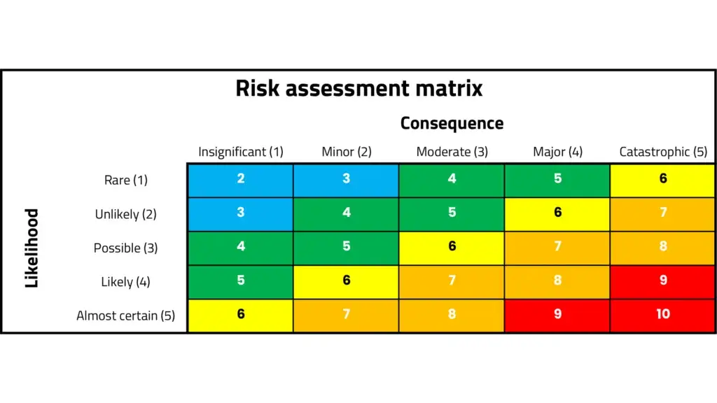
In the case of OP-MedVR. The table below shows the risks, probability of risk occurring, impact on the project delivery, risk level, member responsible for risk prevention, and mitigation steps.
Table 11 Project Risks and Risk Management Plan
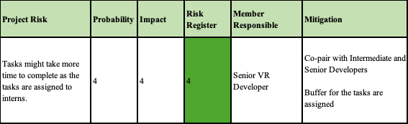

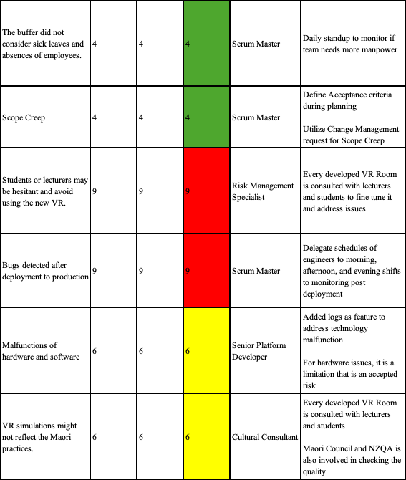

7. Project Organisation

A project organizational structure outlines the roles, responsibilities, and authority of individuals within a project. It specifies each team member’s position and the reporting relationships, typically presented in a chart, to guide team members throughout the project's duration. Project managers utilize project organization to ensure team members are properly aligned both before and throughout the project. This approach helps reduce disruptions and conflicts within the team, fostering a more efficient and productive environment for everyone involved (Martins, 2024).
For the OP-MedVR, There is no Scrum Master role since the plan is to have the whole development team rotate on the Scrum Master role except the Project Manager and the Product Owner (Shuiqing Yu, 2019). The whole development team reports to the Senior Product Owner and the Senior Product Owner and the HR Manager reports to the Project Manager. The student and lecturer assigned by OP reports to the OP.
The table below shows the project organisation structure, their roles, responsibilities, and who they report to.
Table 12 Project Organisation
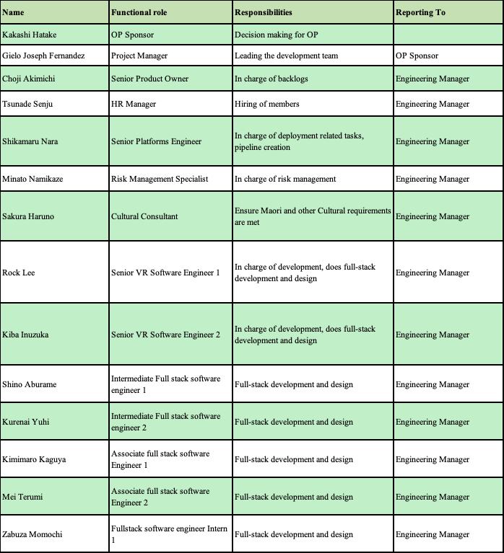
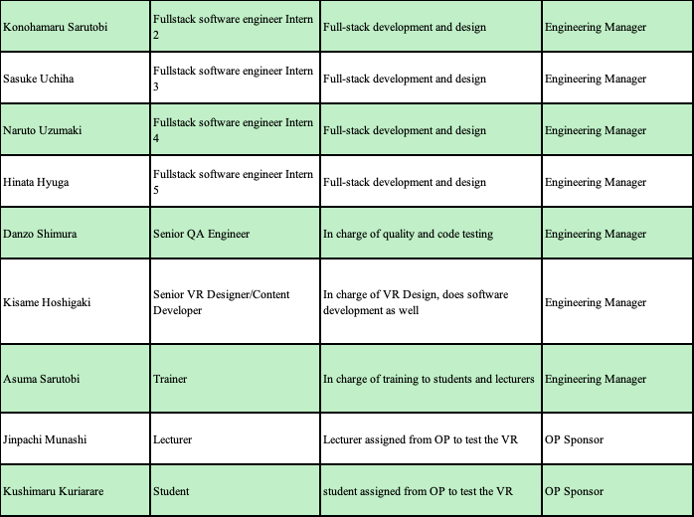

8. Communications with Stakeholders

8.1 Stakeholders identification.
A stakeholder refers to any individual, group, or entity that has an interest or concern in the decisions and operations of a business, organization, or project. Stakeholders may be affiliated with the organization in question, or they might not have any formal connection to it. Stakeholders can impact an organization's activities or projects either directly or indirectly. Their backing is frequently essential for the success of business initiatives and projects (Barney, 2023).
In the case of OP-MedVR, the stakeholders will be the following:
Table 13 Stakeholder Identification
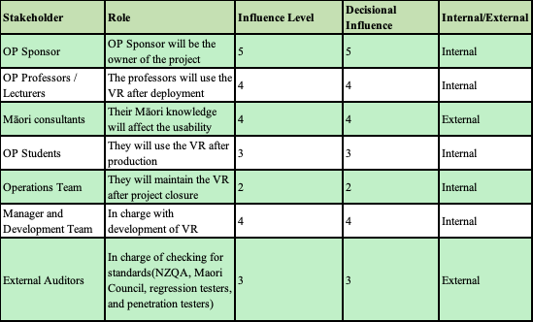

8.2 Communication plan
Agile ceremonies are composed of daily standup, story grooming, sprint planning, sprint review, and sprint retrospective which are used to discuss the project’s next course of action (Laoyan, 2025).
In the case of OP-MedVR, communication with stakeholders will be done during these agile ceremonies. It will be discussed in detail below.
Table 14 Communication Plan
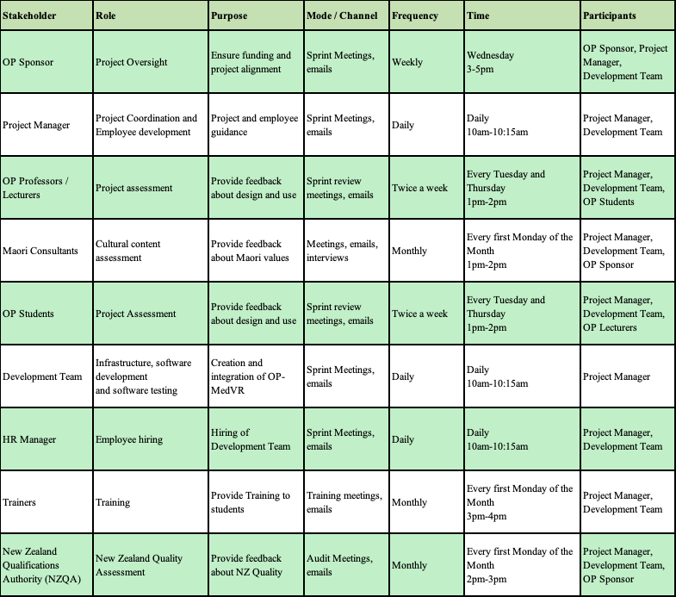

9. Change management plan
Change management helps ensure a project reaches its desired goals by facilitating the necessary transitions for individuals involved. When new technology is introduced, it is essential for employees to embrace and effectively utilize it to create value. When introducing a new process, it’s crucial for employees to embrace and apply it to generate value. Project-level change management offers tailored steps, actions, plans and strategies that specifically address the needs of impacted employees, ensuring alignment with the overall project deployment (Creasey, 2022).
In scrum, changing requirements is quite common. The Agile Manifesto Principle emphasizes embracing changes in requirements, even if they arise late in the development process (Beck et al., 2001). This means that decisions are made based on the results observed, allowing for adjustments as we progress. This approach inherently involves modifying requirements throughout the process (Kulkarni, 2023). The following below are done in the scenario of a change request (Dworniczak, 2025):
The figure below contains the sample change control procedure.
Figure 2 Change Control process
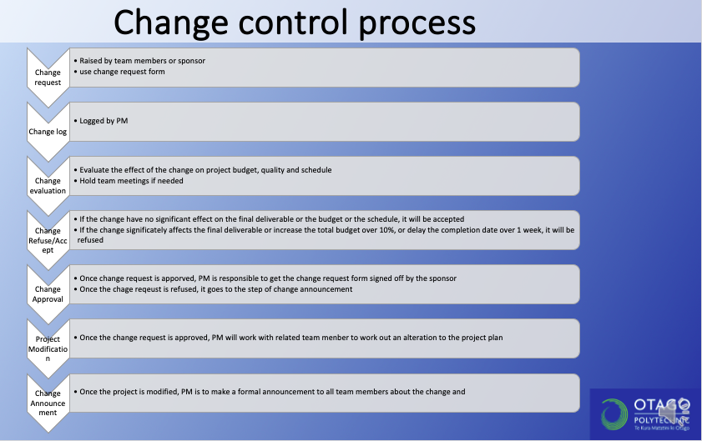
In the case of OP-MedVR, the following is done to assess change request:
- The change request form goes to the Product Owner and the stakeholders. Product owner and the stakeholders checks for cost-benefit effect, risk assessment, resource availability, impact on scope, and priority.
- Once it is approved, the Product Owner discusses with the scrum master and the development team regarding the effect of the change request. For example, the ICU room VR might get delayed in delivery if we apply this change. The development team discusses possible scenarios on how change request will be delivered.
- The Product Owner relays it to the stakeholders the scenarios to see if they will agree to it. The Product Owner then adjusts then backlog based on it.
- The change request then gets implemented based on the priority in the backlog.

Regarding the change request form, the form below is a template that can be used.
Figure 3 Change Request Form (Project Management Docs, 2023)
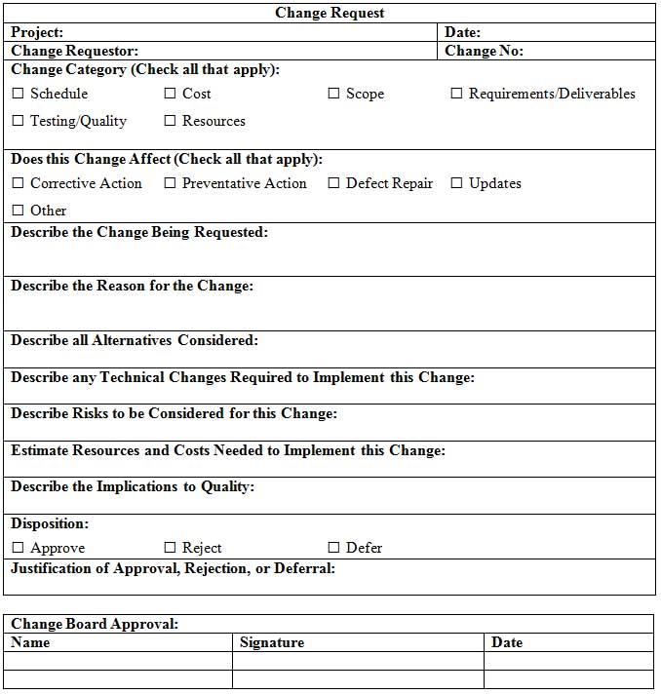

10. Project Estimation Technique
A successful project begins with an accurate estimate. To effectively plan and execute your project, it's essential to understand the timeline, budget, scope, risks, and other critical factors. All these factors are integral to project estimation methods. These techniques assist in determining the feasibility of your project. If you choose to proceed, they are crucial for accurately predicting project outcomes. (Hennesy, 2022). The list below explains some of the estimation methods.
1. Analogous estimation: Analogous estimating is a method used to forecast the costs of current and future projects by referencing a similar project from the past. This approach is considered one of the most precise and detailed techniques for determining cost data, allowing you to establish a reliable cost baseline without the need for complex statistical models (Viter, 2022).
2. Parametric estimation: Parametric estimating is a method that uses statistical analysis and historical data to calculate the time, cost, and resources required for a project's success. By leveraging the relationship between variables, this technique provides precise estimations. Typically used during the planning phase or throughout a project, parametric estimating relies on formulas or algorithms to determine the necessary cost or time to complete tasks or the entire project (Udoagwu, 2022).
3. PERT diagram: A PERT chart is a visual tool that represents a project as a network diagram, with numbered nodes connected by labeled vectors. It helps project managers estimate the shortest time required to complete a project. Additionally, PERT charts allow for the analysis of task dependencies, work breakdowns, and the evaluation of potential project risks. The breakdown structure simplifies the organization of complex projects by visualizing the dependencies between each step, making it easier to manage tasks with various moving parts (Sheldon et al., 2024).
4. Top-down approach: Commonly employed to develop preliminary rough estimates (ballpark figures) during the initial phases of a project, when detailed information is scarce (they may also serve for validation purposes). Top-down estimates typically require less time and effort to generate compared to bottom-up estimates. The primary advantage of top-down estimates is the ability to leverage broader data from past projects or products, including unmanaged risks and scope creep. This approach can help minimize the likelihood of missing work activities or costs (Rowland, 2019).
5. Bottom-up approach: It involves starting with the smallest tasks required for a project and progressively estimating the larger components by working your way up from the details. The strength of this estimation method lies in its exceptional precision. It involves creating a work breakdown structure (WBS) to assess every detail of the smallest tasks required, and then gradually aggregating these estimates to form an overall picture of the project's larger activities. By dividing the project into smaller deliverables and further breaking them down into individual tasks, you can access the specific details needed for accurate estimation (Card, 2024).
6. Three-point estimation: A method employed to evaluate the possible outcomes or costs of future scenarios. This approach allows project managers to create precise forecasts and determine an expected value by conducting a thorough analysis, even when data is scarce. This strategy is highly effective as it incorporates the assessment and combination of multiple projections: the most probable estimate (M), worst-case estimate (P), and the best-case estimate (O). The optimistic estimate represents the best possible outcome, the pessimistic estimate corresponds to the worst possible outcome, and the most likely estimate shows the scenario with the highest probability. (Davis, 2023).
In the case of OP-MedVR, Bottom-up approach and parametric estimation was used since most tasks are related, we can allocate the effort and budget for each specific task in relation to previous tasks (Guthrie, 2023). Bottom-up approach is great for this as well as we get to estimate all the activities needed by breaking it down into smaller tasks (Usifo, 2024).

11. Budget
According to Bridges, (2023b), A project budget details the estimated overall expenses required to complete a project within a specified timeframe. It helps forecast the costs linked to each phase of the project. Developing a project budget is a crucial step in the planning process. It usually includes labor costs, material expenses, and operational expenditures. However, it is not a rigid document and may be adjusted as the project progresses. The project budget should be consistently tracked and updated during the project's course, preferably using project budgeting software for assistance.
In relation to OP-MedVR, the expenses used in the preparation (sprint 0) will include all the necessary equipment and software needed for the duration of the project (5 months). The expenses in the sprints (Sprint 1 – Sprint 10) will focus on the labour costs and 5% for miscellaneous cost. This is under the assumption that licenses and equipment were already purchased during preparation, and that since all the employees are working from home, there is minimal cost in other expenses which will be covered by miscellaneous cost.
The table below contains the general budget breakdown for OP-MedVR.
Table 15 OP-MedVR Budget
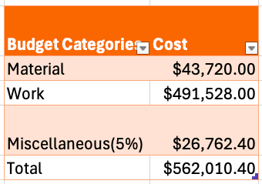
For the budget for materials, the budget allotted is for the duration of the development of OP-MedVR(5 months) and the needed equipment of the development team. The rent and electricity are $0 under the assumption that the whole team is remote/working from home status. The cost on rent and electricity will be considered under miscellaneous.
The table below contains the budget breakdown for materials.
Table 16 OP-MedVR Materials Budget
material | quantity | cost per unit | total cost | purpose | source
Keyboard | 20 pcs | $45.00 | $900.00 | For the use of employees | PowerPlay Keyboard
Mouse | 20 pcs | $20.00 | $400.00 | For the use of employees | Warehouse Mouse
Jira | 5 months | $172.00 | $860.00 | License for use of Jira | Jira
Laptops | 20 pcs | $1,300.00 | $26,000.00 | For the use of employees | Dell Laptop
VR Hardware | 20 pcs | $650.00 | $13,000.00 | For the use of employees | Meta Quest
Unreal Engine License | 0 | $0.00 | $0.00 | license for VR development | Unreal Engine
GitHub | 20 pcs x 5 months | $4.00 | $400.00 | license for GitHub repository | GitHub
Azure Subscription | 5 months | $432.00 | $2,160.00 | license for cloud use | Azure Calculator
Electricity | 0 | $0.00 | $0.00 | no electricity (remote work)
Rent | 0 | $0.00 | $0.00 | no rent (remote work)
Total |  |  | $43,720.00

The rate per hour for each employee were based on the salary sourced from Glassdoor and Seek (2025) as what employers are offering based in current market demand. The annual salary is divided by 52 weeks and then divided by 40 hours per week to get the salary per hour.
For the Work Breakdown Structure, the Work breakdown Structure in the MS Project is not utilised under the assumption that all the employees of the team are working full time in the background(communicating with stakeholders, code reviews, testing features, bug fixes, grooming tasks, etc..) even though they are not assigned a project in MS Project, which implies that they are working 8 hours per day, and 5 days per week. This is in exception to the HR Manager and Trainer, which will only work for 5 days and 6 days respectively.
The table below contains the budget breakdown for Work/Labour.
Table 17 OP-MedVR Work Budget
Role | hours | hourly rate | total cost | source
HR Manager | 8 hours x 5 days | $53.00 | $2,120.00 | HR Manager
Project Manager | 8 hours x 96 days | $51.00 | $39,168.00 | Project Manager
Senior Platforms Engineer | 8 hours x 96 days | $52.00 | $39,936.00 | Senior Platforms Engineer
Risk Management Specialist | 8 hours x 96 days | $34.00 | $26,112.00 | Risk Management Specialist
Cultural Consultant | 8 hours x 96 days | $42.00 | $32,256.00 | Cultural Consultant
Senior Product Owner | 8 hours x 96 days | $48.00 | $36,864.00 | Senior Product Owner
Senior VR Software Engineer 1 | 8 hours x 96 days | $46.00 | $35,328.00 | Senior VR Software Engineer
Senior VR Software Engineer 2 | 8 hours x 96 days | $46.00 | $35,328.00 | Senior VR Software Engineer
Intermediate Full stack software engineer 1 | 8 hours x 96 days | $33.00 | $25,344.00 | Intermediate Full stack software engineer
Intermediate Full stack software engineer 2 | 8 hours x 96 days | $33.00 | $25,344.00 | Intermediate Full stack software engineer
Associate full stack software Engineer 1 | 8 hours x 96 days | $28.00 | $21,504.00 | Associate full stack software Engineer
Associate full stack software Engineer 2 | 8 hours x 96 days | $28.00 | $21,504.00 | Associate full stack software Engineer
Fullstack software engineer Intern 1 | 8 hours x 96 days | $25.00 | $19,200.00 | Fullstack software engineer Intern
Fullstack software engineer Intern 2 | 8 hours x 96 days | $25.00 | $19,200.00 | Fullstack software engineer Intern
Fullstack software engineer Intern 3 | 8 hours x 96 days | $25.00 | $19,200.00 | Fullstack software engineer Intern
Fullstack software engineer Intern 4 | 8 hours x 96 days | $25.00 | $19,200.00 | Fullstack software engineer Intern
Fullstack software engineer Intern 5 | 8 hours x 96 days | $25.00 | $19,200.00 | Fullstack software engineer Intern
Senior QA Engineer | 8 hours x 96 days | $34.00 | $26,112.00 | Senior QA Engineer
Senior VR Designer/Content Developer | 8 hours x 96 days | $35.00 | $26,880.00 | Senior VR Designer/Content Developer
Trainer | 8 hours x 6 days | $36.00 | $1,728.00 | Trainer
Total |  |  | $491,528.00

12. Quality Control and Audit
- Quality Control
Quality control (QC) is a step-by-step process aimed at ensuring that a business maintains or enhances the quality of its products. It involves establishing a culture where both management and employees are committed to continuous improvement and achieving excellence. This is achieved by training staff, setting quality standards for the product, and conducting tests to identify any statistically meaningful deviations (Hayes, 2024).
Regarding OP-MedVR, the table below contains the Audit Control done for the duration of the project.
Table 18 Quality Control for OP-MedVR
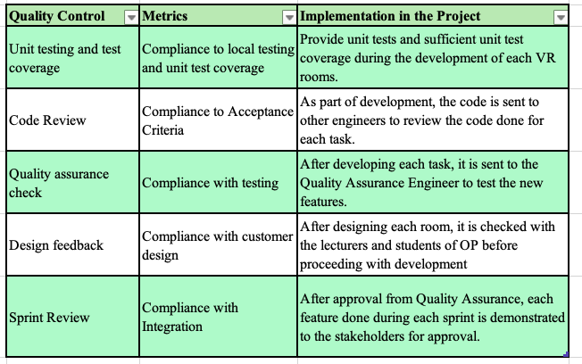
- Audit
The audit aims to assess the progress of a project, ensuring it aligns with the defined statement of work, including the project's scope, timeline, budget, and the maturity of its management processes. Throughout the audit, factors such as scope, schedule, quality, costs, resources, and risks are reviewed to confirm that the project is adhering to its original plan (Bridges, 2023a). However in agile teams, the process sometimes deviates to address certain issues, which is expected as stated in the Agile Manifesto, “Individuals and interactions over processes and tools” (Beck et al., 2001). The auditor should communicate with Product Owner and Scrum master to ensure that agile practices were followed (Nair, 2019). In OP-MedVR, the auditor should check the artifacts created during sprint planning, review and retrospective, as well as product backlogs..
Before pushing to production, we use this table (below) to help set up the OP-MedVR audit.
Table 19 Audit Check for OP-MedVR
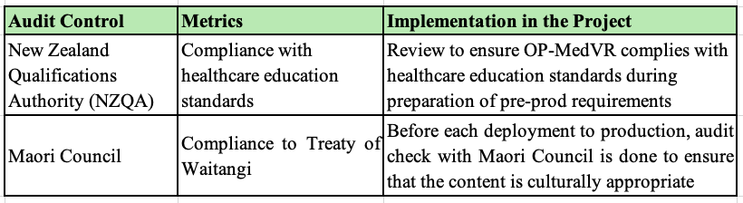

13. Project Closure
According to Sengupta, (2023), the closure of an Agile project is a crucial stage that guarantees a seamless conclusion while gathering important lessons for future projects. In contrast to traditional approaches, Agile project closure follows an iterative process and is consistent with Agile principles. To ensure the successful transfer of ownership from the Agile team to the operations team, the following items below are done to make sure we tie up any loose ends (Cosgrove & Hubbard, 2020).
In regards to OP-MedVR, the table below contains the actions done during project closure.

Table 20 Project Closure for OP-MedVR

14. Appendices

Senior VR Designer/Content Developer - $35 per hour
https://www.glassdoor.co.nz/job-listing/game-director-lead-game-designer-tencent-JV_IC3525162_KO0,32_KE33,40.htm?jl=1009649781596&cs=1_3e9eaa24&s=343&t=SR-JOBS-HR&pos=102&src=GD_JOB_AD&guid=00000195b2a948ee89ebfea76a296686&uido=65FC4472BDEC32AAD12883C19DB458B2&jobListingId=1009649781596&ao=1136043&vt=w&jrtk=5-pdx1-0-1impaij15gqmt800-af997ef44ac85d47&cb=1742459194620&ctt=1742459202771

Trainer - $36 per hour
https://www.seek.co.nz/job/82815772?type=standard&ref=search-standalone&origin=cardTitle#sol=84016d139461aca38e6d722bb3f7f84abd331b3e
Developer Intern - $25 per hour
https://www.sjs.co.nz/job-details/21526/mechatronics-rnd-engineer-intern-casualpartfull-time-cbd/

Laptops - $1300 x 20 = $26000
https://www.dell.com/en-nz/shop/dell-laptops/inspiron-15-laptop/spd/inspiron-15-3520-laptop/oin3520100901mnzh?ref=variantstack

Keyboard - $45 x 20 = 900
https://www.pbtech.co.nz/product/KEYEBL1026/PowerPlay-E-Blue-Mechanical-Sense-RGB-Gaming-Keybo?srsltid=AfmBOooLZOmmTw6reVHHwSRwjH_6l9iixH98waNnHECwnCvt0Ds56fdIxjI&gStoreCode=PBAucklandCBD

Mouse - $20 x 20 = $400
https://www.thewarehouse.co.nz/p/logitech-m190-full-size-wireless-mouse---blue-910-005914/M18529702.html?srsltid=AfmBOortW7da92oV1ogJUmJ3HhpLUx3YZDpAapauHqF3Qt9arrRaK8aDHzI

VR hardware - $650 x 12 = $7800
https://www.pbtech.co.nz/product/MVRMTA0024/META-Quest-3s-128GB-Mixed-Reality-Headset-with-2x?qr=GShopping&gad_source=1&gclid=Cj0KCQjw-e6-BhDmARIsAOxxlxVaWUoXJIuyEoiQJ3eRXoX368WtnsJzZHLHL6e3mIZI5g8FZ-UVGZwaAntYEALw_wcB

Azure Subscription - $432 per month
https://azure.microsoft.com/en-us/pricing/calculator/?ef_id=_k_Cj0KCQjw-e6-BhDmARIsAOxxlxX14GT6Xgk_PIpmy9nZve2RbTFsrkhuQPFPnsWSuwNOKvzvVE6FhBAaAhw8EALw_wcB_k_&OCID=AIDcmmp3m06wb2_SEM__k_Cj0KCQjw-e6-BhDmARIsAOxxlxX14GT6Xgk_PIpmy9nZve2RbTFsrkhuQPFPnsWSuwNOKvzvVE6FhBAaAhw8EALw_wcB_k_&gad_source=1&gclid=Cj0KCQjw-e6-BhDmARIsAOxxlxX14GT6Xgk_PIpmy9nZve2RbTFsrkhuQPFPnsWSuwNOKvzvVE6FhBAaAhw8EALw_wcB
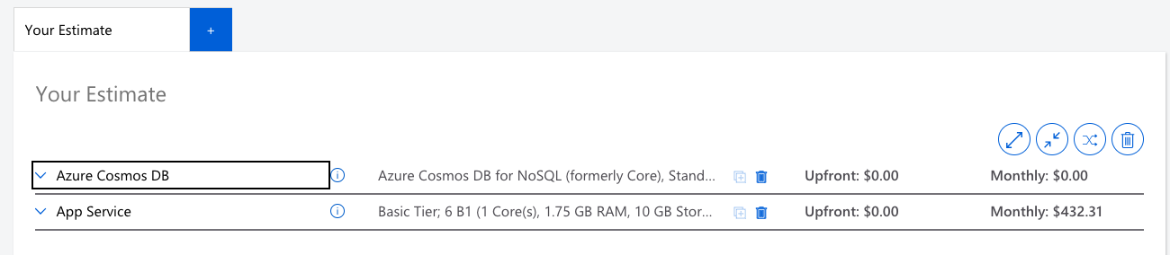

VR Software Licenses - free
https://www.unrealengine.com/en-US/license


Github - $4 x 20 = $80 per month
https://github.com/pricing
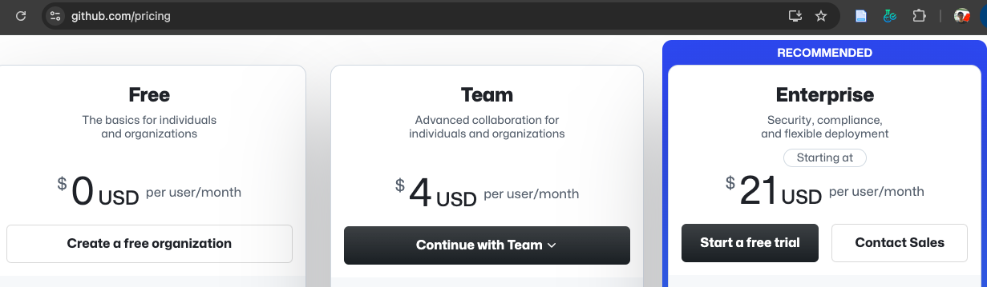

Jira - $8.6 x 20 = $172 per month
https://www.atlassian.com/software/jira/pricing
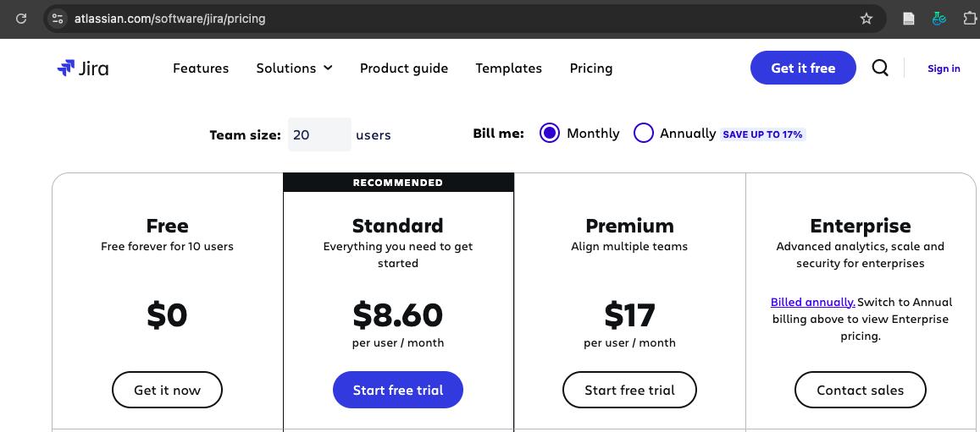

15. References:
Althiyabi, T., & Qureshi, R. (2021). Predefined project scope changes and its causes for project success. International Journal of Software Engineering & Applications (IJSEA), 12(2/3).
Barney, N. (2023). Stakeholder. TechTarget. https://www.techtarget.com/searchcio/definition/stakeholder
Beck, K., Cohn, M., Jeffries, R., Anderson, D., Beedle, M., Boehm, B., Combemale, B., Highsmith, J., Hunt, A., Kern, P., Larman, C., Martin, R., Mellor, S., Schwaber, K., Sutherland, J., & Thomas, D. (2001). The Agile Manifesto. Agile Alliance. http://agilemanifesto.org/
Bridges, J. (2023a). How to Do a Project Audit: A Quick Guide. ProjectManager.Com. https://www.projectmanager.com/training/project-management-audit
Bridges, J. (2023b). How to Make a Project Budget: Project Budgeting Basics (Templates Included). ProjectManager.Com. https://www.projectmanager.com/training/create-and-manage-project-budget
Bridges, J. (2024). How to Write Effective Project Objectives & Goals Every Time. https://www.projectmanager.com/training/how-to-write-effective-project-objectives-every-time
Card, K. (2024). Accurate Project Estimations: A Deep Dive Into Bottom-up Estimation. UseMotion.Com. https://www.usemotion.com/blog/bottom-up-estimating
Cosgrove, E., & Hubbard, K. (2020). Agile closing out project. Action Engineering Blog. https://www.action-engineering.com/blog/agile-closing-out-project/
Creasey, T. (2022). Change Management at the Project Level. Prosci. https://www.prosci.com/blog/change-management-at-the-project-level
Davis, K. (2023). Three-Point Estimating: Definition, Formula, Example. KnowledgeHut Blog. https://www.knowledgehut.com/blog/project-management/three-point-estimating
Dworniczak, M. (2025). Understanding Change Requests in Scrum. LinkedIn. https://www.linkedin.com/pulse/understanding-change-requests-scrum-mariusz-mario-dworniczak-pmp-i26bf
Eby, K. (2021). Essential Guide to Project Organizational Structure. https://www.smartsheet.com/content/project-management-organization?srsltid=AfmBOoo1noRBtZhQ4hZJVw7TRajpVMRSrta9YgIbSvq2FbhXB16auQu4
Erro, S. (2016). Limitations vs. Constraints. https://medium.com/@SteveErro/limitations-vs-constraints-575d9334ed2f
Espinheira, E. (2021). Management Fix. ILLUMINATION. https://medium.com/illumination/management-fix-9a4ce364ced2
Fowler, K. (2010). Chapter 1—Best Practices in Mission-Assured, Mission-Critical, and Safety-Critical Systems. In K. Fowler (Ed.), Mission-Critical and Safety-Critical Systems Handbook (pp. 1–82). Newnes. https://doi.org/10.1016/B978-0-7506-8567-2.00001-9
Goldfedder, J. (2020). Finding Your Purpose: Project Deliverables. In J. Goldfedder (Ed.), Building a Data Integration Team: Skills, Requirements, and Solutions for Designing Integrations (pp. 49–73). Apress. https://doi.org/10.1007/978-1-4842-5653-4_4
Guthrie, G. (2023). How to use parametric estimating to improve project performance. Nulab. https://nulab.com/learn/project-management/how-to-use-parametric-estimating-to-improve-project-performance/
Hayes, A. (2024). Quality Control: What It Is, How It Works, and QC Careers. Investopedia. https://www.investopedia.com/terms/q/quality-control.asp
Hennesy, M. (2022). Project Estimation Techniques. ProjectManager.Com. https://www.projectmanager.com/blog/project-estimation-techniques
Kharlantseva, M. (2025). What Is a Deliverable? Understanding Project Outputs and Expectations. Everhour Blog. https://everhour.com/blog/what-is-a-deliverable/
Krüger, G. (2024). Non-functional Requirements: What They Do, Examples, and Best Practices. https://www.perforce.com/blog/alm/what-are-non-functional-requirements-examples#:~:text=Non%2Dfunctional%20requirements%20are%20the,usability%2C%20reliability%2C%20and%20scalability.
Kulkarni, S. (2023). Change Management in Scrum. World of Agile. https://worldofagile.com/blog/change-management-in-scrum/
Laoyan, S. (2025). Understanding the 4 Agile ceremonies. Asana. https://asana.com/resources/agile-scrum-ceremonies
Lock, D. (2017). The Essentials of Project Management (4th, Ed.). Routledge.
Martins, J. (2024). Step-by-step guide to the risk management process. https://asana.com/resources/project-risk-management-process
Nair, B. (2019). Auditing Agile Projects & Agile Auditing- A primer. LinkedIn. https://www.linkedin.com/pulse/auditing-agile-projects-auditing-primer-biju-nair
Project Management Docs. (2023). Change Request Template. Project Management Docs. https://www.projectmanagementdocs.com/template/project-documents/change-request/#google_vignette
Pym, D. V. (1987). Risk Management. PM Network, 1(3), 33–36.
Rebrova, A. (2024). Functional vs Non-Functional Requirements in Software Development. Mad Devs Blog. https://maddevs.io/blog/functional-vs-non-functional-requirements/
Rowland, M. (2019). Three ways to approach cost estimation. APM.Org.Uk. https://www.apm.org.uk/blog/three-ways-to-approach-cost-estimation/
Sengupta, S. (2023). Project closure strategy for agile project. Medium. https://medium.com/@mailme.senguptasudipta/project-closure-strategy-for-agile-project-0744c8440a86
Sharma, N. (2024). Project assumptions: Guide to identify, evaluate & manage risks. ProofHub. https://www.proofhub.com/articles/project-assumptions
Sheldon, R., Chai, W., & Brush, K. (2024). What is a PERT chart? And how to use it, with examples. TechTarget. https://www.techtarget.com/searchsoftwarequality/definition/PERT-chart
Shuiqing Yu, J. (2019). Five Benefits of a Rotating Scrum Master. https://www.linkedin.com/pulse/five-benefits-rotating-scrum-master-shuiqing-yu-joseph/
Udoagwu, K. (2022). The Ultimate Guide to Parametric Estimating in Project Management. Wrike.Com. https://www.wrike.com/blog/guide-to-parametric-estimating-in-project-management/
Usifo, D. (2024). How to Use Bottom-Up Estimating in Project Management. DeeProjectManager.Com. https://deeprojectmanager.com/bottom-up-estimating-project-management/
Viter, I. (2022). Understanding the Analogous Estimating Technique. Runn.Io. https://www.runn.io/blog/analogous-estimating
Wootton, P. (2024). Project Scope Statement. https://www.projectmanagement.com/wikis/961606/project-scope-statement#_=_

